Fuel-Related Scan Data
Meets NATEF Task: (A8-B-6) Diagnose driveability and emissions problems resulting from malfunctions of interrelated systems; determine necessary action. (P-1)

Name _______________________________ Date ___________ Time on Task __________

Make/Model/Year _________________ VIN ________________ Evaluation: 4 3 2 1

_____ 1. Check service information for the specified octane rating and/or alcohol type to be
used.

Recommended octane of gasoline = _________________________

Recommended alcohol type and percentage (if equipped for alcohol or flexible
fuel use) = ________________________ ___________

_____ 2. Connect a scan tool to the data link connector and check for fuel-related data. Check
all that apply.

NOTE: Use the vehicle specific or enhanced version to get the most information from the vehicle.
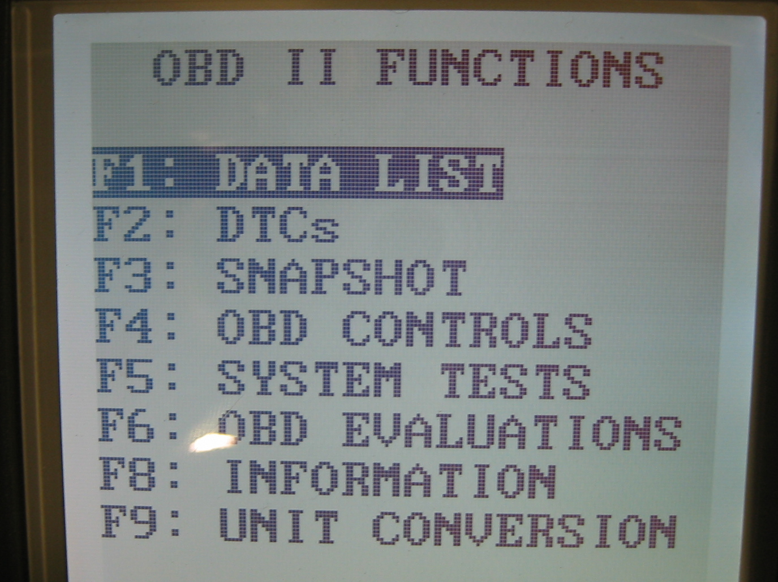

________ Calculated octane

________ Gallons of fuel remaining

________ Percentage of alcohol in the
fuel (flexible fuel vehicle)

________ Fuel pressure

________ Fuel temperature

________ Other (list and/or describe) __________________________________

_____ 3. Based on the results of the information obtained and the specification for the vehicle,
what is the interpretation of the data?

__________________________________________________________________
__________________________________________________________________

