Vehicle Emission Rating

Meets NATEF Task: (A8-A-2) P-1 Research applicable vehicle and service information.

Name _______________________________ Date ___________ Time on Task __________

Make/Model/Year _________________ VIN ________________ Evaluation: 4 3 2 1

_____ 1. Check service information and/or the vehicle emission control information (VECI)
label under the hood to determine national and California standards. (check all that
apply)

National Standard

____ Tier 1
____ Tier 2
____ Bin (list number) ____________
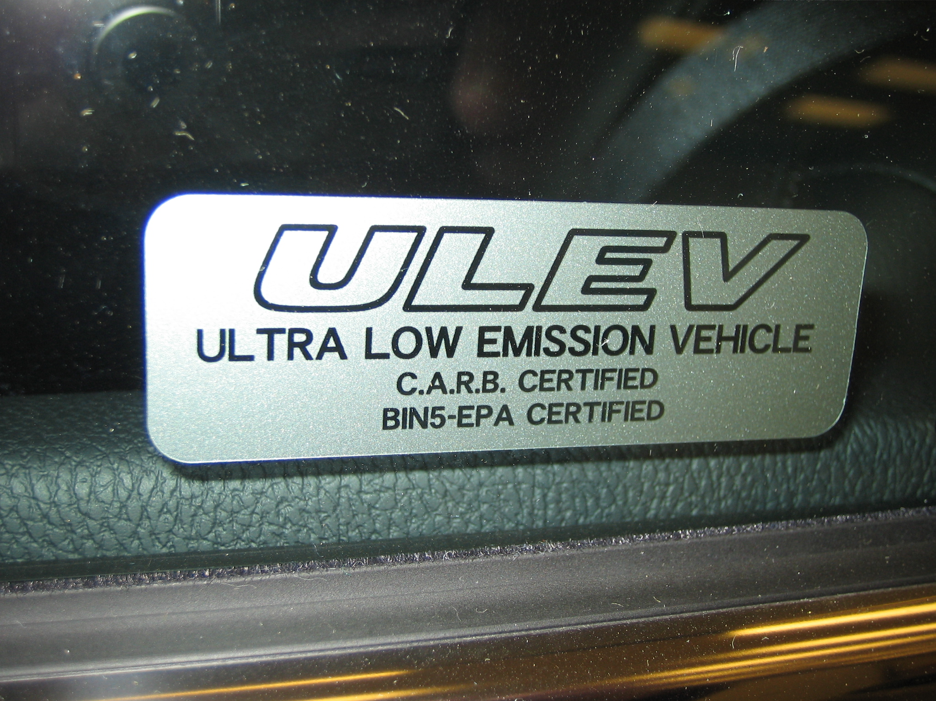
California Standard
____ TLEV
____ LEV (LEV I)
____ ULEV
____ SULEV
____ ZEV
____ PZEV
____ ILEV
____ AT-PZEV
____ NLEV

_____ 2. Define the specified rating. ______________________________________________
_________________________________________________________________
_________________________________________________________________

