Diagnose Electrical/Electronic Concerns
Meets NATEF Task: (A2-A-11) P-1 (A8-B-8) P-2 Diagnose electrical/electronic concerns using principles of electricity.

Name _______________________________ Date ___________ Time on Task __________

Make/Model/Year _________________ VIN ________________ Evaluation: 4 3 2 1

_____ 1. Check service information and determine the specified tests and procedures to follow
when diagnosing electrical/electronic concerns. Describe specified procedures. _______
____________________________________________________________________
____________________________________________________________________
____________________________________________________________________
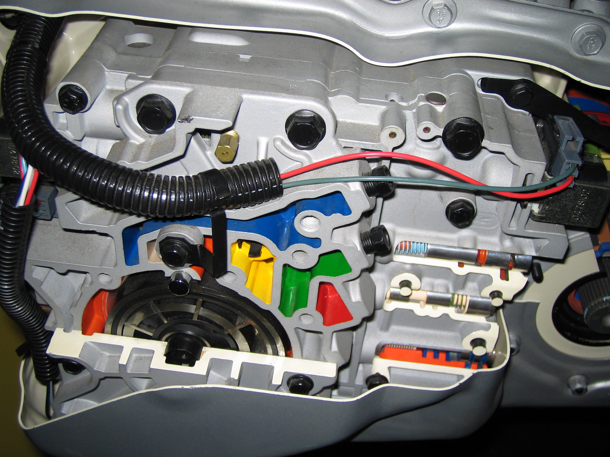
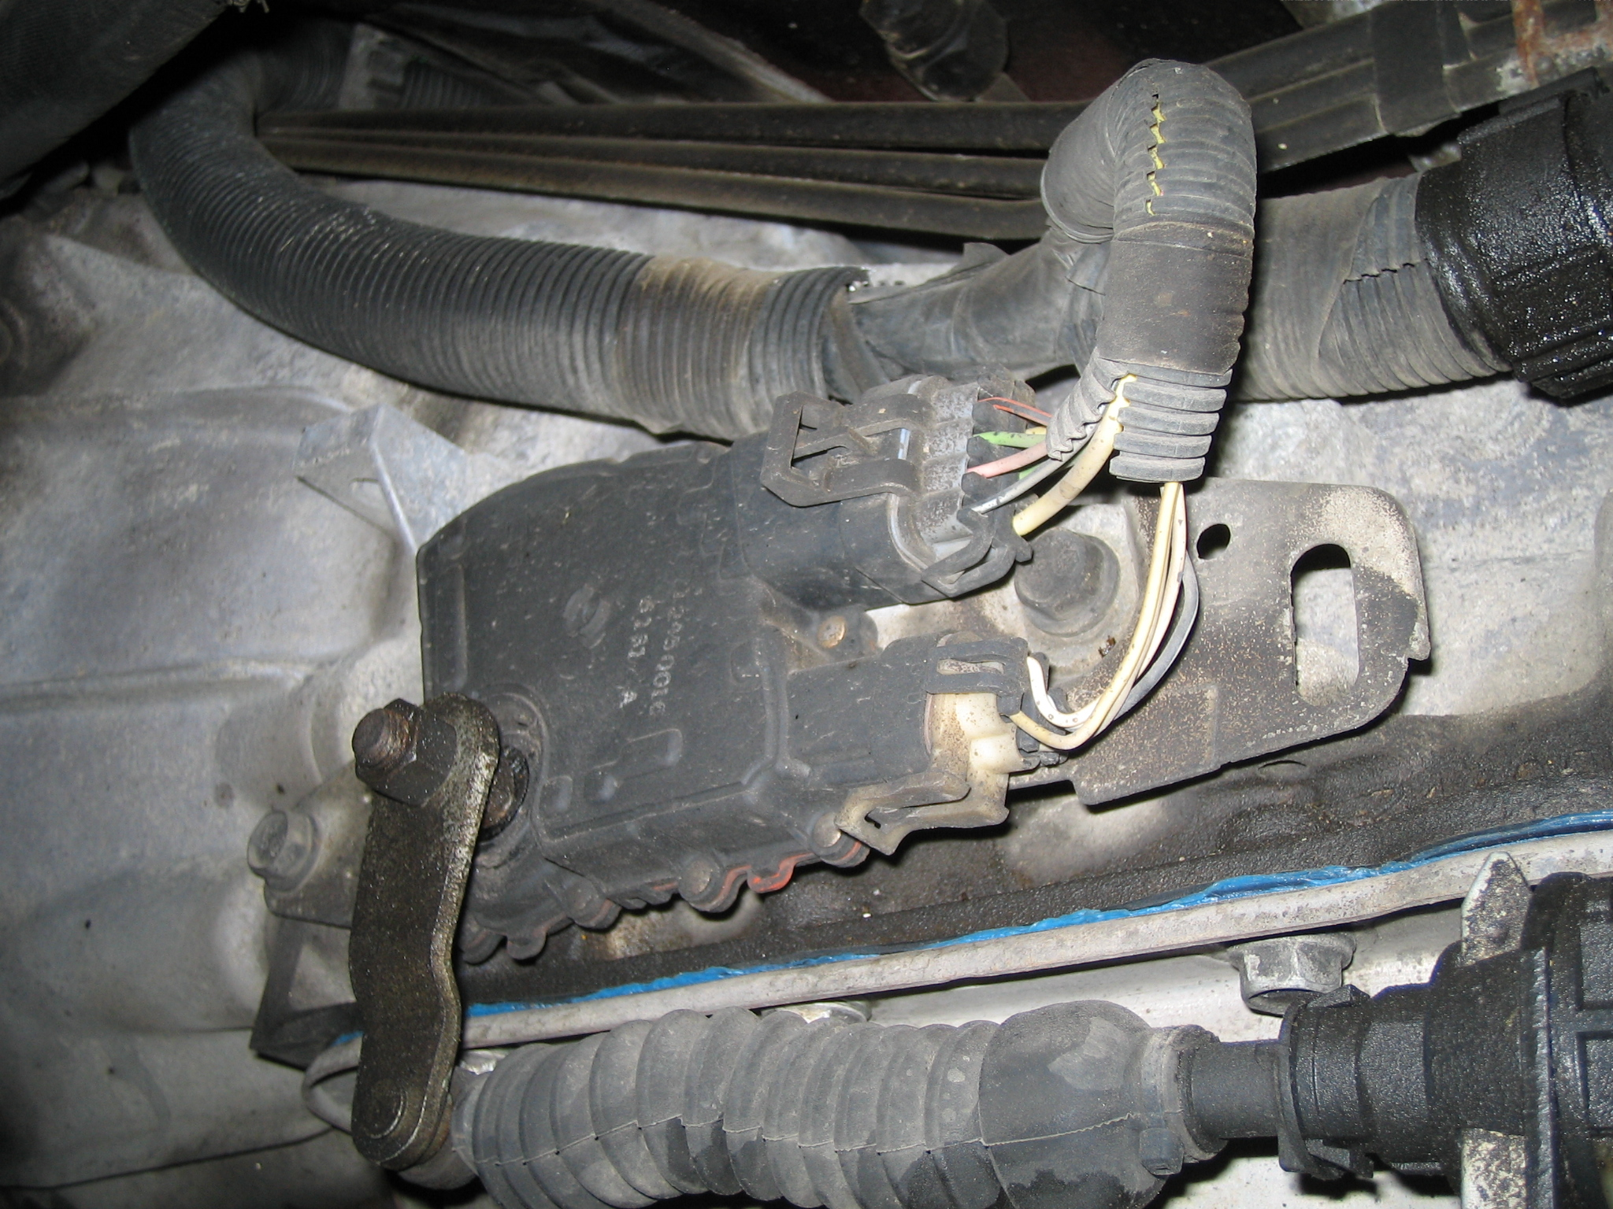

_____ 2. What tools/test equipment is specified to be used during the diagnosis of
electrical/electronic concerns? Check all that apply.
____ Scan tool
____ DMM
____ Special tester (describe) __________________________________________
____ Other (Describe) ________________________________________________

